NIKE-STYLE ECOMMERCE
PROJECT BRIEF
Architecture & Technology Documentation
1. Project Overview
The project is a modern Nike-style eCommerce web application.It allows users to browse and purchase products online.The application provides a clean, attractive, and responsive interface. Users can explore products through categories and collections.Each product has detailed information, images, pricing, and availability.Users can add products to their shopping cart.Users can manage product quantities and remove items from the cart.
The system supports user registration, login, and authentication.Product, user, cart, and order data are stored in PostgreSQL.The application is built using Next.js, TypeScript, Tailwind CSS, and Drizzle ORM.Zustand is used to manage client-side application state.The main goal is to create a scalable eCommerce MVP with a premium shopping experience.

2. Problem Statement
- Traditional online shopping websites can sometimes have complicated interfaces.
- Users may find it difficult to quickly discover suitable products.
- Slow page loading can negatively affect the shopping experience.
- Poor product organization makes browsing difficult.
- Users need clear product information before making a purchase.
- Managing cart items should be simple and convenient.
- Secure authentication is required to protect user accounts.
- eCommerce applications need efficient database management.
- Product images and assets should load quickly.
- Developers also need an architecture that can be easily maintained.
- The project addresses these problems through a modern and responsive design.
- It combines performance, usability, authentication, and scalable data management.
3. Objectives
- To develop a modern Nike-inspired eCommerce MVP.
- To provide a simple and user-friendly shopping experience.
- To create responsive pages for desktop, tablet, and mobile devices.
- To allow users to browse products easily.
- To provide detailed information for every product.
- To implement secure user authentication.
- To provide an efficient shopping cart system.
- To store application data using PostgreSQL.
- To use Drizzle ORM for efficient database operations.
- To improve performance using caching and modern Next.js rendering techniques.
- To create a clean and modular application architecture.
- To build a foundation that can be extended into a complete eCommerce platform.
4. Target Users
- The primary users are customers who want to shop for products online.Users can browse different product categories and search for products based on their requirements.Customers can view product images and detailed descriptions.
- Users can compare products based on price and available information.Registered users can securely log in to their accounts.Customers can add products to their shopping cart.
- Users can update quantities or remove products from the cart.Users can review their selected products before checkout.
- The application can also support administrators for product management.Administrators can manage product information and inventory.The system is designed for users who prefer a fast and modern online shopping experience.
5. Scope
- The project covers the development of an eCommerce MVP.
- It includes a responsive home page and product listing pages.
- Users can browse products by categories and collections.
- The system includes individual product detail pages.
- User registration and login functionality are included.
- The project includes shopping cart management.
- Product, user, and cart information are stored in the database.
- API routes are used to communicate between the frontend and backend.
- The project includes basic order-related functionality where required.
- Performance techniques such as caching, SSR, ISR, and CDN support are considered.
- An admin-side product management system can be included within the MVP scope.
- Advanced features such as real payment processing, logistics, and large-scale recommendation engines can be added in future versions.

6. Key Features
- Modern Home Page – Attractive Nike-style landing page with featured products.
- Product Catalog – Displays products in an organized and responsive layout.
- Product Categories – Allows users to browse products by category.
- Product Details – Shows images, price, description, sizes, and availability.
- Search – Helps users quickly find products.
- Authentication – Provides secure signup, login, and user sessions.
- Shopping Cart – Allows users to add, remove, and update products.
- State Management – Zustand manages cart and other client-side states.
- Database – PostgreSQL stores users, products, carts, and orders.
- API Integration – API routes handle product and shopping-related operations.
- Responsive Design – Provides a consistent experience across mobile, tablet, and desktop.
- Performance Optimization – Uses Next.js rendering, caching, and CDN strategies for faster page loading.
7. Technology Stack & Why It Is Used
- Next.js 15: Used to build the full-stack application with routing, server rendering, API capabilities, and a modular architecture.
- TypeScript: Provides type safety and helps reduce development errors in a large application.
- Tailwind CSS: Used to create a modern, responsive UI quickly with utility classes.
- Better Auth: Handles user authentication, login, signup, and secure sessions.
- Neon PostgreSQL: Provides reliable cloud PostgreSQL storage for products, users, carts, and orders.
- Drizzle ORM: Provides type-safe and efficient database operations from the TypeScript application.
- Zustand: Manages client-side state such as cart items, quantities, and selected UI state.
- CDN: Helps deliver images and static assets quickly from locations closer to users.
- SSR: Used where server-side rendering improves initial loading and SEO, especially for product/catalog pages.
- ISR: Allows relatively stable pages to be regenerated periodically without rebuilding the entire application.
- PPR: Helps combine static and dynamic content so static sections can appear quickly while dynamic sections are rendered as needed.
- Caching: Reduces repeated data fetching and improves application response time.
- API Routes: Provide backend endpoints for products, carts, users, orders, and related operations.
8. High-Level Architecture
- User → Next.js Frontend → Server/API → Drizzle ORM → Neon PostgreSQL
- Next.js + TypeScript + Tailwind CSS are used to build the user interface.
- Zustand manages client-side state such as the shopping cart.
- Better Auth manages authentication and user sessions.
- API routes connect frontend actions with backend business logic.
- Drizzle ORM provides the database access layer.
- Neon PostgreSQL stores persistent application data.
- SSR, ISR, PPR, caching, and CDN strategies are used to improve performance.
9. Expected Outcome
- A functional and responsive Nike-style eCommerce MVP.
- A clean and scalable project structure suitable for further development.
- A smooth product browsing and shopping-cart experience.
- Secure authentication and session management.
- Efficient PostgreSQL database integration.
- Type-safe database operations using Drizzle ORM.
- Improved performance through appropriate rendering and caching strategies.
- A strong architecture foundation for future payment, order, and admin features.

NIKE-STYLE ECOMMERCE MVP
2. REQUIREMENTS
Functional Requirements • Non-Functional Requirements • User Roles
  - Functional Requirements

- The system shall allow users to register, log in, and log out securely.
- Users shall be able to browse products by categories such as shoes, clothing, and accessories.
- Users shall be able to search and filter products based on relevant product information.
- Users shall be able to view product details, images, price, size, description, and availability.
- Users shall be able to add products to the shopping cart.
- Users shall be able to update product quantities and remove products from the cart.
- The system shall allow users to review their cart before placing an order.
- The system shall store and retrieve users, products, carts, and orders using PostgreSQL.
- Admin users shall be able to add, update, and manage product information.
- The application shall provide backend operations through API routes and server actions for product, cart, order, and user operations.

2.2 Non-Functional Requirements
- The application shall provide a fast and responsive user experience.
- The UI shall work properly on mobile, tablet, and desktop devices.
- The system shall use secure authentication and session management.
- The application shall be designed with a modular and maintainable architecture.
- Database operations shall be efficient and reliable using PostgreSQL and Drizzle ORM.
- Appropriate SSR, ISR, PPR, and caching strategies shall be used to improve page performance.
- Product images and static assets should be delivered efficiently through a CDN.
- The application should be scalable so additional products, users, and features can be supported.
- TypeScript shall be used to improve type safety and reduce development errors.
- The system should provide reliable error handling and maintain data consistency and security.
NIKE-STYLE ECOMMERCE MVP
3 User Roles
3.1 Customer / User
- Customers can create an account and securely log in.
- Customers can browse and search for available products.
- Customers can view detailed product information.
- Customers can add products to and remove products from their cart.
- Customers can update product quantities before checkout.
- Customers can place and review their orders.
- Customers can manage their basic account information.
- Customers can interact with the application through a responsive interface.
3.2 Admin
- Admin users can securely access the admin dashboard.
- Admins can add new products to the catalog.
- Admins can update product names, prices, descriptions, images, and availability.
- Admins can remove or deactivate products when required.
- Admins can manage product categories and inventory information.
- Admins can view and manage customer orders.
- Admins can monitor basic user and product information.
- Admin functionality helps maintain the eCommerce platform and its catalog.

4. User Flows – Nike-Style
eCommerce MVP

4.1 Login / Register Flow

- The user opens the eCommerce website.
  - The user selects Login or Register.
  - For a new account, the user enters name, email, and password.
  - The system validates the registration details.
  - The user account is created and stored securely.
  - An existing user enters their email and password.
  - The authentication system validates the credentials.
  - After successful authentication, a secure user session is created.
  - The user is redirected to the home page or previous page.
  - If authentication fails, the system displays an appropriate error message.

Flow:
Website → Login/Register → Validate → Better Auth → User Session → Home/Product Page

4.2 Browse / Search Products Flow

  - The user opens the product catalog.
  - The system retrieves available products from the database.
  - Products are displayed using a responsive product grid.
  - The user can browse products by category.
  - The user can search for a specific product.
  - The system processes the search request.
  - Matching products are displayed to the user.
  - The user can apply filters such as category, size, or price.
  - The user selects a product to view its details.
  - The product detail page displays images, price, description, size, and availability.

Flow:
User → Catalog → Search/Filter → API/Server → Database → Product Results → Product Details

4.3 Product → Cart → Checkout Flow

  - The user opens a product detail page.
  - The user selects the required size or product option.
  - The user selects Add to Cart.
  - The selected product is added to the cart.
  - Zustand manages the cart state on the client side.
  - The user opens the shopping cart.
  - The user can increase, decrease, or remove product quantities.
  - The system calculates the cart subtotal and other applicable amounts.
  - The user selects Proceed to Checkout.
  - The checkout page displays the order summary and required customer information.

Flow:
Product → Select Options → Add to Cart → Zustand → Cart → Review → Checkout

4.4 Payment → Order Confirmation Flow

  - The user reviews the products and total amount at checkout.
- The user enters or selects the required shipping information.
  - The system validates the checkout information.
  - The user selects a supported payment method.
  - The payment request is sent to the payment service.
  - The payment service processes and verifies the transaction.
  - After successful payment, the order is created in the database.
  - The system generates an order ID/confirmation.
  - The user is redirected to the order confirmation page.
  - The confirmation page displays order details and payment status.

Flow:
Checkout → Payment → Payment Gateway → Payment Verification → Create Order → Database → OrderConfirmation

MVP note: If real payment integration is outside your current scope, you can use a mock payment flow andclearly mention real payment gateway integration as a future enhancement.

4.5 Admin Workflow

  - The admin opens the admin login page.
  - The admin enters valid credentials
  - Better Auth verifies the admin account and role.
  - After successful authentication, the admin dashboard is displayed.
  - The admin can view the product catalog and inventory information.
  - The admin can add a new product with its details and images.
  - The admin can update product price, description, size, or availability.
  - The admin can deactivate or remove products when required.
  - The admin can view and manage customer orders.
  - Product and order changes are stored in PostgreSQL through Drizzle ORM.

Flow:
Admin Login → Authentication → Admin Dashboard → Products/Orders → API/Server Actions → Drizzle ORM → PostgreSQL

5. Technical Architecture Nike-Style
eCommerce MVP

5.1 Architecture Overview

The eCommerce application follows a modern three-tier architecture consisting of the Presentation Layer,Application/Backend Layer, and Database Layer. The frontend provides a responsive shopping experience, whilethe backend manages authentication, products, cart, orders, payments, and admin operations. PostgreSQL is used or reliable and structured data storage.

5.2 Frontend Layer

The frontend is developed using Next.js and React.js. It provides pages for user registration, login, producbrowsing, product details, cart, checkout, order history, and user profile. Responsive UI is implemented using HTML, CSS, Bootstrap/Tailwind CSS, allowing the application to work across desktop, tablet, and mobile device.

5.3 Backend Layer

The backend handles business logic and provides REST/API endpoints for the frontend. It manages authentication, product operations, cart management, order processing, payment integration, and user management. API routesvalidate requests, apply business rules, communicate with the database, and return appropriate responses.

5.4 Authentication & Authorization

User authentication is implemented using secure login and registration mechanisms. Passwords are stored usingsecure hashing rather than plain text. Authentication tokens/session information are used to maintain logged-in users. Role-based authorization separates normal customers from administrators and restricts access to admin functionality.

5.5 Database Layer

PostgreSQL is used as the primary relational database. It stores users, products, categories, carts, cart items,orders, order items, payments, and addresses. Relationships and foreign keys maintain data consistency and prevent invalid records.

5.6 API Layer

The application uses REST-style APIs for communication between the frontend and backend. Common operationsinclude:

- GET – Retrieve products/orders/data
- POST – Create users, cart items, orders, etc.
- PUT/PATCH – Update existing records
- DELETE – Remove records

API validation and proper HTTP status codes are used to handle successful and failed requests.

5.7 Payment Layer

The checkout module connects with a third-party payment gateway. When the customer confirms an order, thepayment service processes the transaction and returns the payment status. The application records the transaction status and updates the corresponding order after successful payment.

5.8 Admin Layer

The admin dashboard allows authorized administrators to manage products, categories, inventory, users, orders, and payment/order status. Admin APIs are protected using role-based authorization so that normal customers cannot access administrative operations.

5.9 Security

Security is considered throughout the application. Important measures include password hashing, authenticationand authorization, input validation, API protection, HTTPS, secure environment variables, database constraints, and protection against common attacks such as SQL injection and unauthorized access.

5.10 Deployment Architecture

The frontend/backend application can be deployed on a cloud platform, while PostgreSQL can be hosted using amanaged database service. Environment variables are used for database credentials, authentication secrets, payment keys, and other sensitive configuration. A CI/CD pipeline can be used to automatically build, test, and deploy new versions.

5.11 High-Level Architecture Flow

- User → Next.js/React Frontend → API/Backend → Business Logic → PostgreSQL Database

- For payment:

User → Checkout → Backend API → Payment Gateway → Payment Response → Order Database → OrderConfirmation

- For administration:

Admin → Admin Dashboard → Protected Admin API → Business Logic → PostgreSQL

6 . Nike-Style eCommerce MVP

6.1Database Design
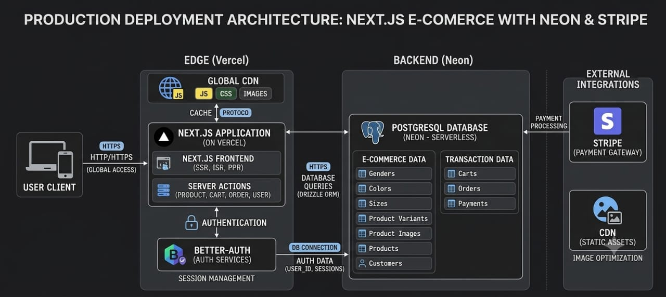

6.2 ER Diagram

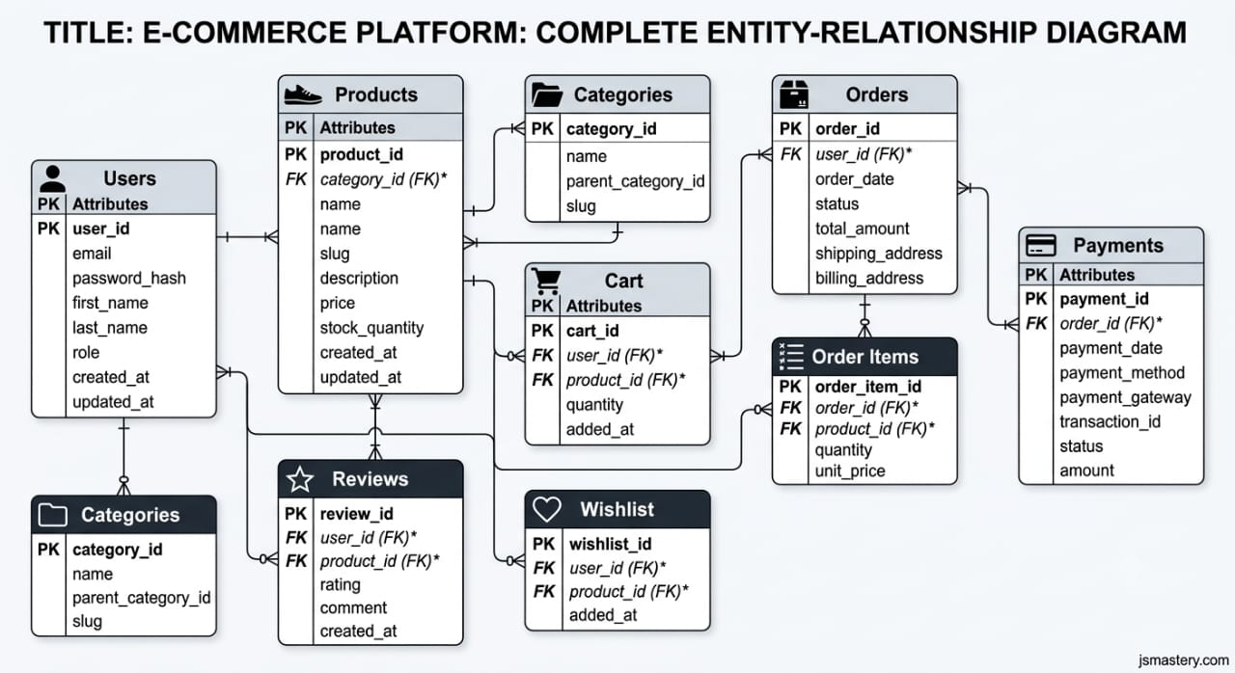

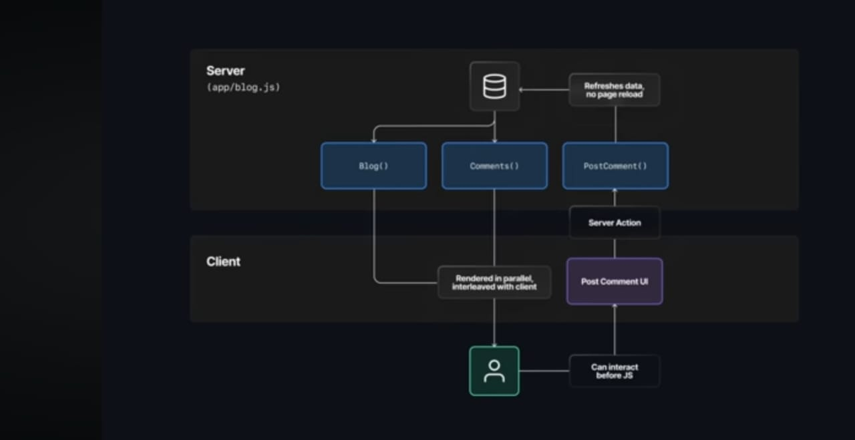

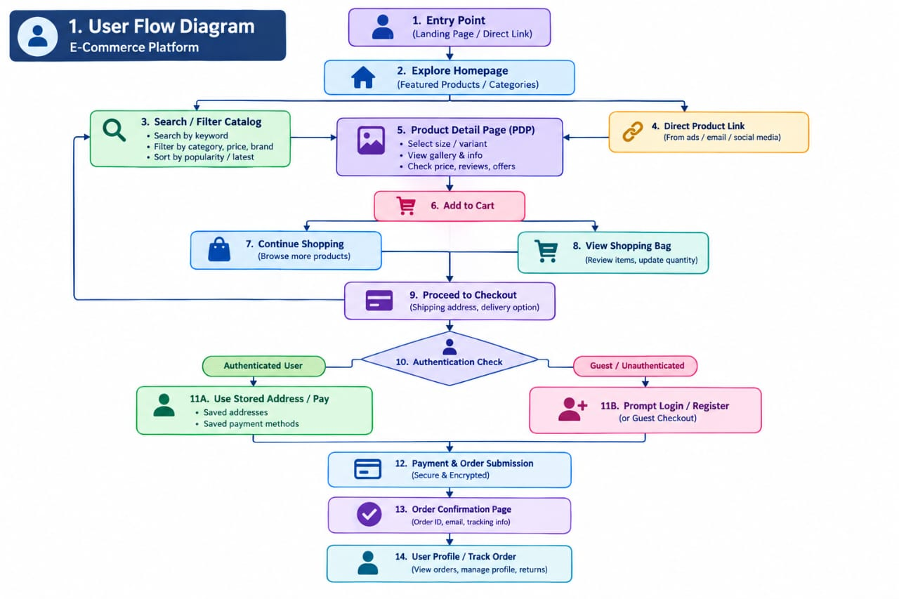

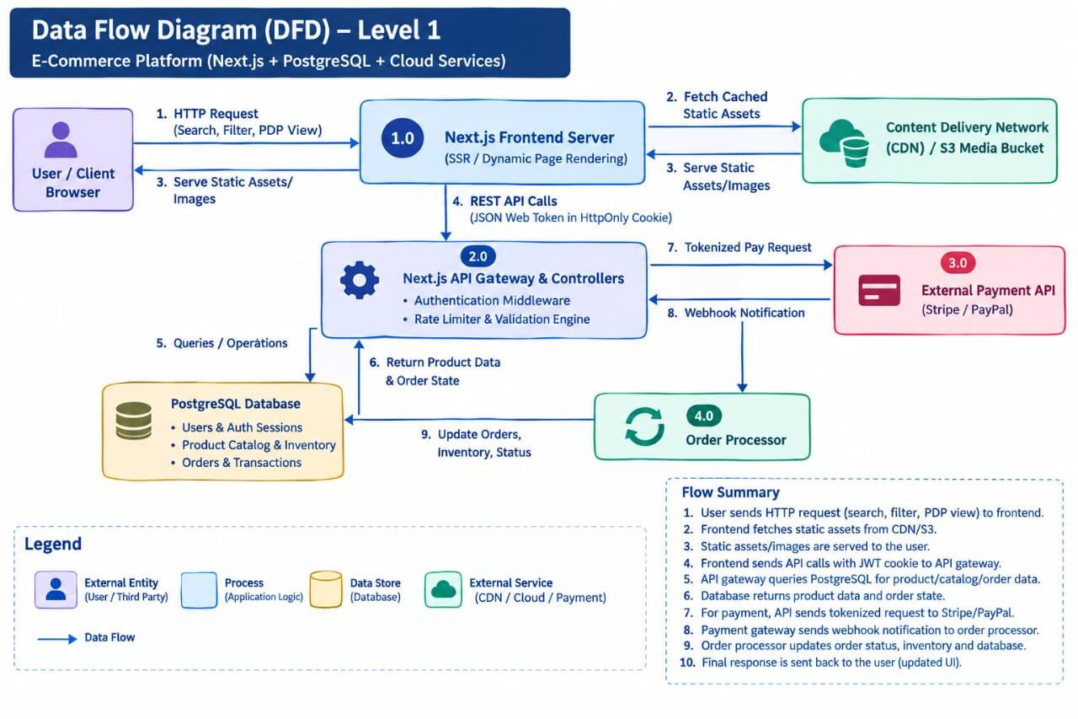

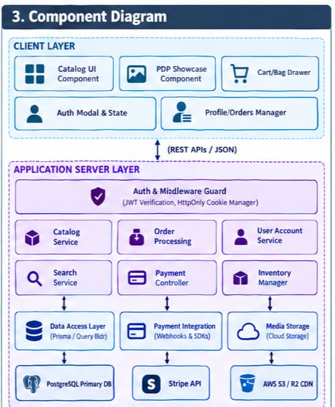
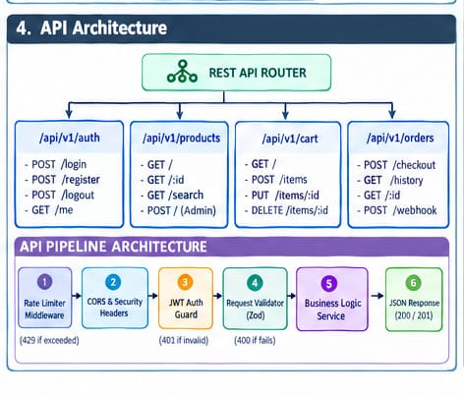

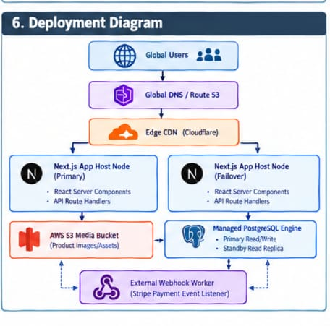

7. Authentication

- Authentication & Security

- JWT / Session Authentication: Uses Better-Auth (an open-source auth framework for Next.js) tomanage modern session states and tokens cleanly across client and server
- Password Hashing: Handled under the hood by Better-Auth using standad, secure cryptographic algorithms (e.g., argon2 or bcrypt) prior to storing credentials in PostgreSQL.
- Role-Based Access (RBAC): Defined directly within the relational database schema (using Drizzle ORM) to segregate customer features from administrative privileges.
- Input Validation: Uses Zod schema validation across Next.js Server Actions and form submissions to sanitize and type-check payloads before processing.
- API Authorization: Handled via Next.js Server Actions and API middleware to verify active session headers before serving sensitive user data or mutation logic.
- SQL Injection Protection: Prevented natively by Drizzle ORM, which utilizes parameterized query generation across all database queries instead of raw string concatenation.
- XSS & CSRF Protection:
- XSS: Next.js / React automatically escapes JSX content.
- CSRF: Modern HTTP-only, SameSite cookies generated by Better-Auth prevent cross-site requestforgery.
- Secure Payment Processing: Integrates Stripe (via Stripe Model Context Protocol / SDKs) to process payments externally without handling raw credit card data on custom servers.

8. Performance & Scalability

- Database Indexing: Configured inside Drizzle ORM schemas on frequently queried columns (such as product_id, category, user_id, and created_at) to optimize read latency.
- Pagination: Implemented at the API/database query level (limit and offset / cursor-based pagination) to stream product listings efficiently rather than fetching whole datasets .
- Image Optimization: Powered by Next.js <Image/> component, which handles automatic WebP/AVIF format conversion, dynamic resizing, and lazy loading.
- CDN (Content Delivery Network): Leveraged at the Vercel/Edge level to store and serve static pages, assets, and ISR responses close to global users .
- Caching & ISR: Uses Next.js Incremental Static Regeneration (ISR) and dynamic caching layers at the edge to reduce database reads on static catalog pages .
- Lazy Loading: React/Next.js dynamic imports (next/dynamic) and native visual loading states delay loading non-essential components until rendered in the viewport.
- API Optimization: Employs Next.js Server Actions for low-latency client-to-server data manipulation without unnecessary HTTP request overhead .

9. Deployment Architecture

- Frontend & API Layer (Vercel): The Next.js app deploys to Vercel's global Edge Network. Server Actionsand API routes run as serverless/edge functions, ensuring low-latency rendering globally.
- Databae Hosting (Neon / Supabase): PostgreSQL is deployed on a serverless provider like Neon or Supabase with poolers configured to handle transient serverless connections.
- Static Asset CDN: Next.js automatically offloads dynamic images, CSS, and JS bundles to Vercel's CDN forinstant global distribution.
- ORM & Migrations: Drizzle ORM runs migrations during the continuous integration / continuous deployment (CI/CD) build pipeline before deploying code to production.

10. Testing Strategies & Tools

- Unit Testing: Tests isolated functions, utilities, and React UI components using Jest or Vitest alongsideReact Testing Library.
- API Testing: Validates Next.js Server Actions and API routes by testing inputs, responses, and authorization checks using Supertest or direct runner queries.
- Integration Testing: Tests database operations, Drizzle ORM queries, and multi-step actions (e.g., adding to cart, user profile updates) using Vitest connected to a test PostgreSQL database.
- UI (End-to-End) Testing: Simulates real browser interactions (checkout flows, navigation, UI rendering) using Playwright or Cypress.
- Security Testing: Checks for vulnerabilities via automated static code analysis (SonarQube / ESLint Security Plugin), dependency scanning (npm audit / Snyk), and payload sanitization validation (Zod schemas.

11. Wireframes

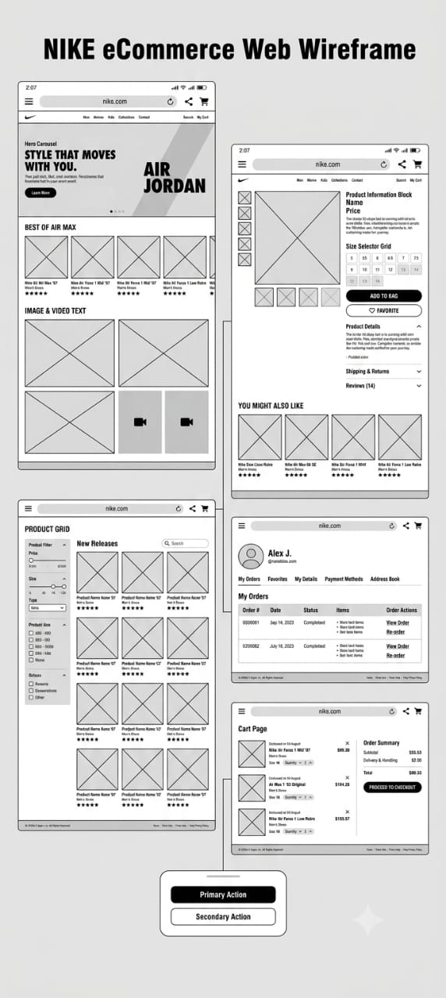
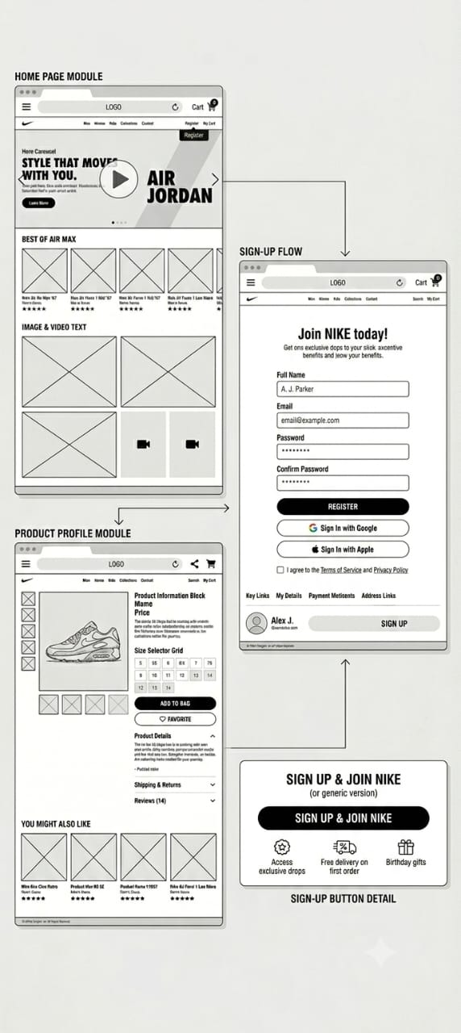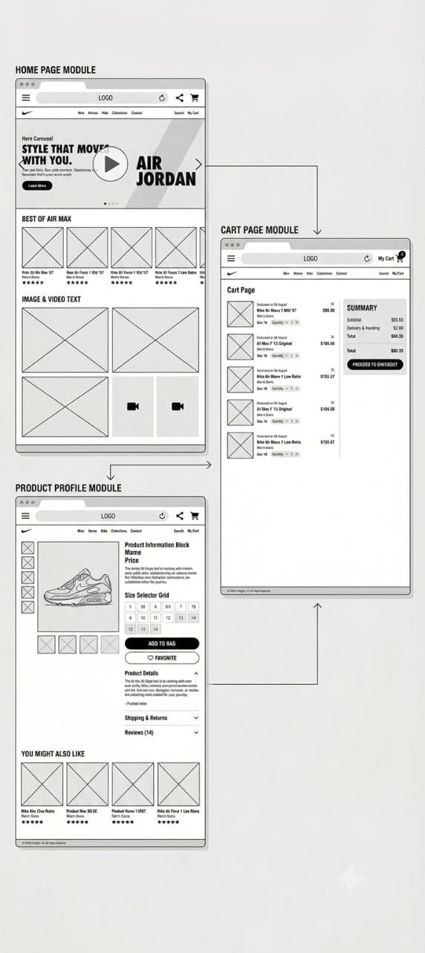

12. Design Decisions

- Why Next.js?
SEO Optimization & Fast Initial Load: Utilizes Hybrid Rendering (Server-Side Rendering for dynamic catalog pages and Static Site Generation for landing pages), ensuring search engine crawlers index product pages effectively while maintaining low First Contentful Paint (FCP).
Built-in Image Optimization: Features automatic image resizing, modern format conversion (.webp/.avif), and responsive loading to handle high-fidelity product assets without degrading performance.
Unified Full-Stack Architecture: Simplifies project structure by combining React UI components and backend API routes within a single cohesive framework.

- Why PostgreSQL?
ACID Compliance & Relational Integrity: Essential for e-commerce transactions, ensuring strict data consistency across complex relational models (users, orders, line items, inventory, and payment logs).
Advanced Querying & Full-Text Search: Provides powerful indexing mechanisms (B-Tree, GIN, GiST) and built-in full-text search capabilities for product indexing without requiring immediately separate search clusters.
Extensibility & Reliability: Robust ecosystem with proven horizontal/vertical scalability and support for JSONB data types to store flexible product metadata.

- Why REST API?
Predictability & Standardization: Uses standard HTTP methods (GET, POST, PUT, DELETE) and status codes, establishing clear contracts between client interfaces and server services.
Caching Efficiency: Leverages HTTP-level caching headers (ETag, Cache-Control) and CDN edge caching to quickly deliver product catalog data to users worldwide.
Widespread Compatibility: Simple to consume, debug, and document (via OpenAPI/Swagger), ensuring seamless integration for future mobile applications or third-party partner services.

- Why JWT / Session Authentication?
Stateless Scalability with JWT: JSON Web Tokens allow microservices and serverless functions to verify user credentials independently without querying session databases on every request.
Enhanced Security via HttpOnly Cookies: Storing tokens in HttpOnly, SameSite=Strict cookies prevents client-side JavaScript access, effectively mitigating Cross-Site Scripting (XSS) and Cross-Site Request Forgery (CSRF) vulnerabilities.
Flexible Authorization: Token payloads carry user roles and permissions (Customer, Admin), enabling quick client-side and API-level route protection.

- Why Cloud Storage?
High Availability & Durability: Offloads media asset hosting (high-resolution product images, promotional videos) to scalable cloud infrastructure (e.g., AWS S3, Cloudflare R2).
Global CDN Integration: Pairs natively with Content Delivery Networks (e.g., Cloudflare, AWS CloudFront) to serve assets from edge locations nearest to the end user, dramatically reducing latency.
Reduced Application Server Load: Prevents application servers from handling static file upload bandwidth and disk storage management.

- Why Payment Gateway Integration?
PCI-DSS Compliance Outsourcing: Handles sensitive credit card data directly through tokenized webhooks and secure SDKs (e.g., Stripe, PayPal), removing PCI compliance burdens from company servers.
Multi-Currency & Localized Payment Methods: Provides instant access to global payment options including Apple Pay, Google Pay, Buy Now Pay Later (BNPL), and local cards.
Built-in Fraud Detection: Utilizes gateway-level machine learning models to detect fraudulent transactions and handle chargeback disputes efficiently.

13.Figma Design

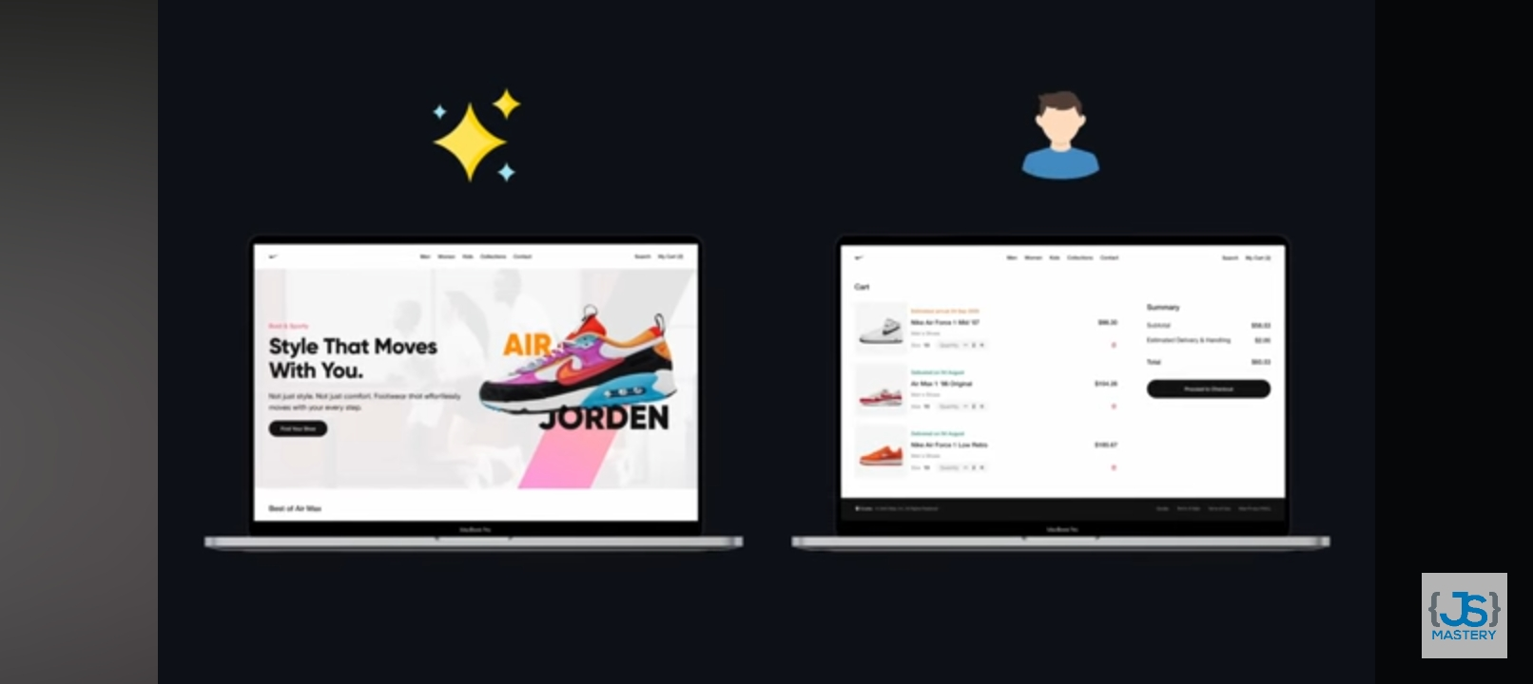

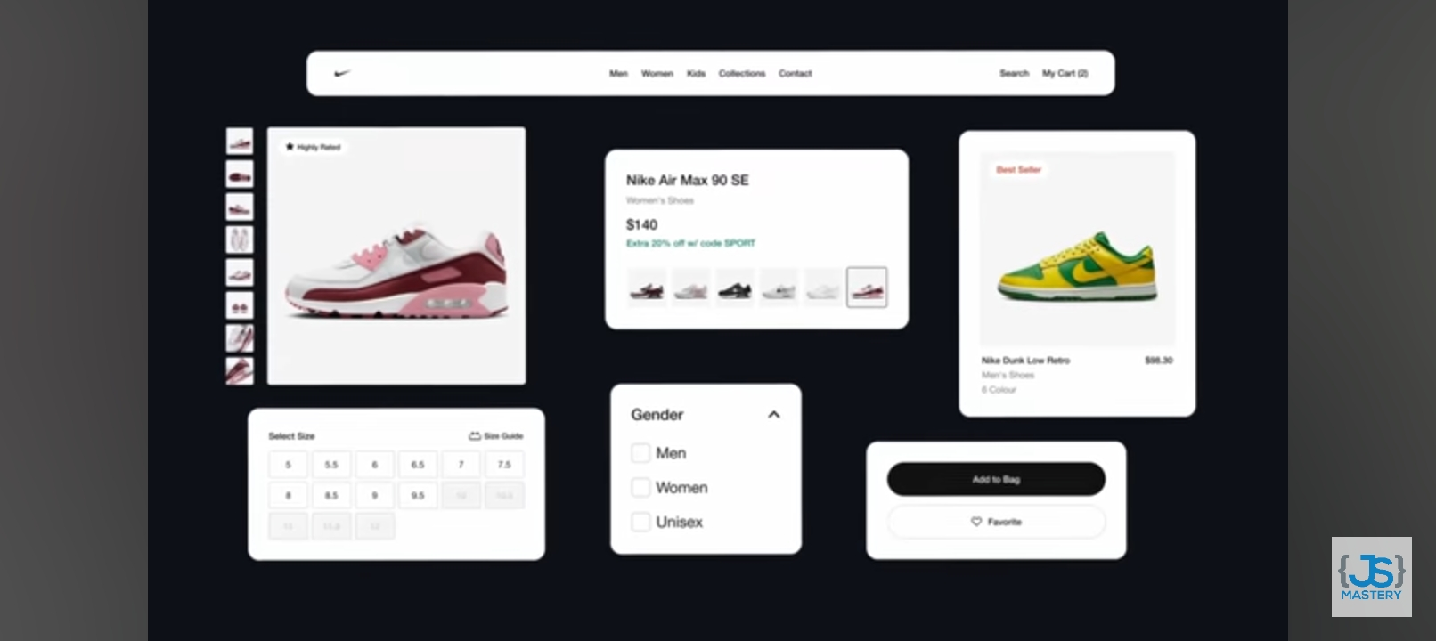

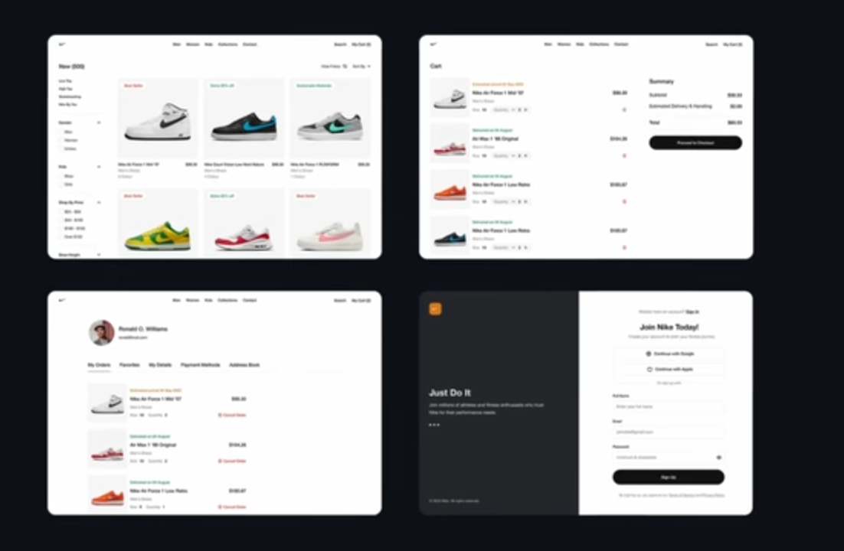

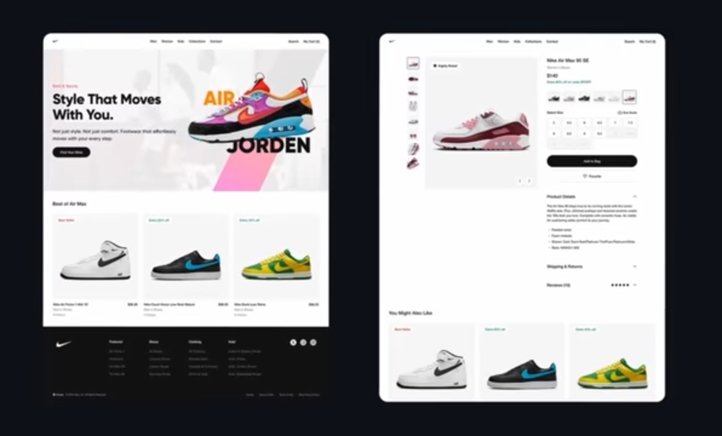

14.Future Enhancements

- AI Recommendations Engine
Implement collaborative filtering and content-based recommendation models to offer personalizedproduct suggestions ("Complete the Look", "Customers Also Bought") based on user browsing history and purchasing patterns.

- 24/7 AI Customer Assistant (Chatbot)
Deploy an LLM-powered chatbot trained on product sizing guides, return policies, and FAQs to assistusers instantly, lowering support ticket volume.

- Personalized Offers & Dynamic Pricing
Develop real-time segmentation algorithms that trigger contextual discount codes, member-tier rewards, and cart-abandonment offers based on user behavior.
Real-Time Order Tracking & Live Push Notifications
Integrate WebSockets or Server-Sent Events (SSE) combined with third-party logistics APIs (e.g., FedEx, UPS) to display live map tracking from warehouse dispatch to door delivery.

- AI-Driven Inventory Prediction
Utilize predictive time-series models (e.g., Prophet, ARIMA) to forecast SKU demand by analyzing historical sales data, seasonal spikes, and regional market trends to prevent stockouts and overstocking.

15. Conclusion
The designed e-commerce platform provides a modern, scalable, and high-performance foundation tailored for premium retail user experiences. By combining a Next.js front-end with a PostgreSQL database and cloud-native services, the architecture balances visual appeal with operational reliability, security, and SEO optimization.
The modular design decisions ensure that as business requirements expand, the application can effortlessly integrate advanced AI features, real-time tracking, and intelligent inventory management—positioning the platform for long-term growth and high customer engagement.

